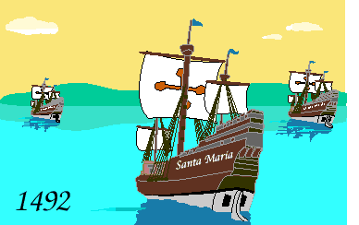

7:00 Open
Call to Order
7:30 Citizen Comments
Approval of Minutes
Appointments

7:35 Library Trustees

Cultural Council Appointments

Old Business
New Business

- One Day License Request from Bartending Service of New England
- One Day License Request from The Silent Chef
- One Day License Request from North River Theatre
- Request from the Women’s Club to hold Turkey Trot Road Race
- Approve Ballot Question for Special Election
- Discussion on Warrant Articles
- Emergency Information Notification

Upcoming Meetings
Announcements
Adjournment
Executive Session
Happy Columbus Day!

